Weather Location Application (Android)
Weather Location Application is an android application which uses Android phone’s GPS to tract the exact location of the user. Using that location, the application calls the API of Open Weather Map, fetches the JSON data, parses the fetched data and show the data on the screens.
The application contains following functions
- Getting weather conditions for current location.
- Getting weather conditions for every 3hour-slots.
- Getting weather conditions for daily (Up to 7 days).
- Getting weather conditions for nearby cities on the Google Map.

Known Issues
- The API is not stable. Sometime although the location is correct, the data for hourly weather condition is empty.
- In getting daily weather forecast from API, the date is incorrect (for example, showing 1970 in the year)
- Since the application entirely depends on the device GPS, the application will not work when the GPS or internet is turned off.
- Since using third party libraries like Volley and Picasso is prohibited, the images bitmaps are loaded in the image view synchronously which makes the application’s performance slower.

Remarks
The application uses Google Map API so the new google Map API key is required to run the google Map in the application. Please follow the following steps to get an API key from Google Developer console.
- Open the app in android studio. Click “gradle” in the top right corner. Click on the project and then on “singingReport”. Copy the SHA1 key. Refer to the following screeen.
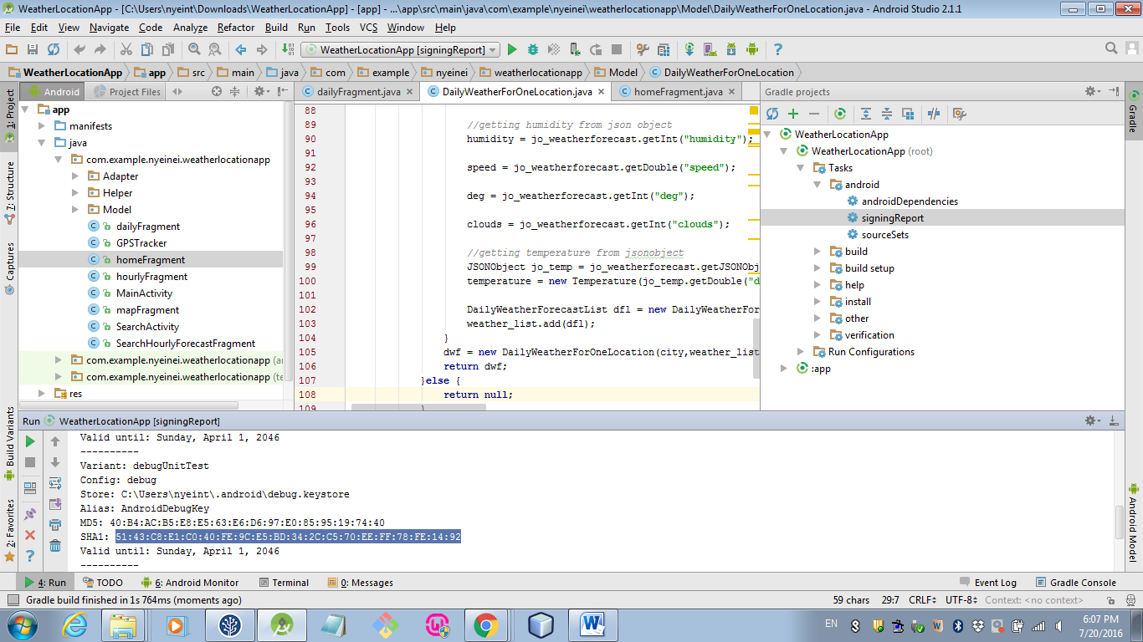

- Go to https://console.developers.google.com/apis and click “Google Map Android API”. If the Google Map Android API button is disabled, click “enable”.
- Go to Credentials. Click “create credentials”, click “API key” and choose “Android Key”. Click “add package name and fingerprint”. In the package name, fill in the application package name and in SHA1- certificate fingerprint, fill in the SHA1 key of the project. Refer to the following screen.
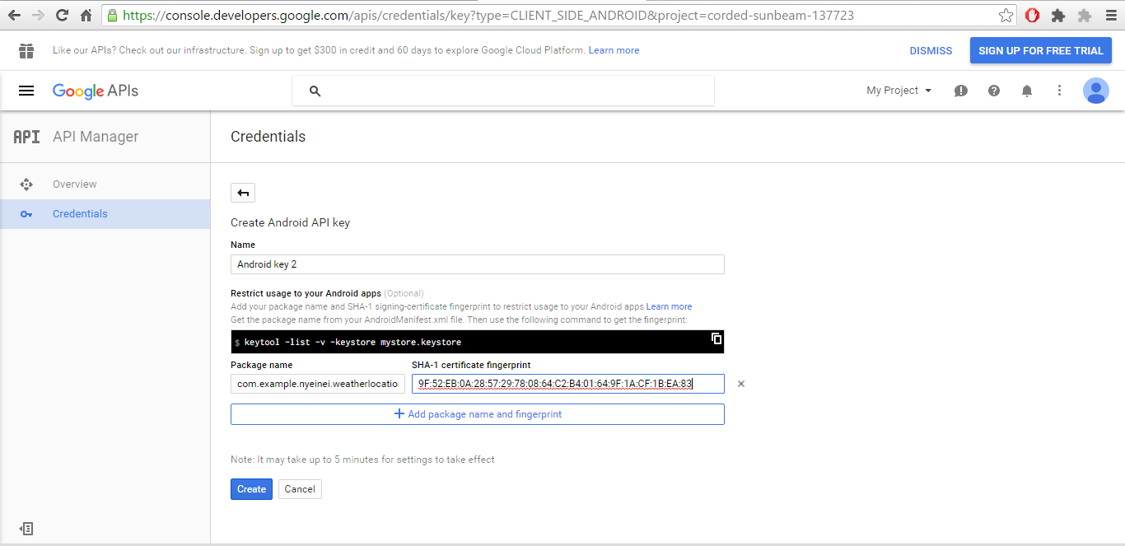
- Click “Create” and get the key. Go to the manifest file of the application and paste the key in the following lines.
<meta-data
android:name="com.google.android.geo.API_KEY"
android:value="Your_key_here" />

